Project Planning Phase
Project Planning Template (Product Backlog, Sprint Planning, Stories, Story points)

Date | 30 September 2026
Team ID | SWTID-2026-6276
Project Name | AI StudyBuddy API – Deliver Intelligent, Personalized Study Assistance
Maximum Marks | 5 Marks

Product Backlog, Sprint Schedule, and Estimation (4 Marks)
Use the below template to create product backlog and sprint schedule
Sprint | Functional Requirement (Epic) | User Story Number | User Story / Task | Story Points | Priority | Team Members
Sprint-1 | Project Setup | USN-5 | As a developer, I can set up the Node.js/Express project, install dependencies and configure the environment (MVC structure). | 5 | High | Sasidharan S, Sanjaikarthikeyan S K
Sprint-1 | Database Configuration | USN-6 | As a developer, I can design Mongoose User and Topic schemas and connect to MongoDB. | 5 | High | Rohit S, Santhakumar B
Sprint-1 | Registration | USN-1 | As a user, I can register with name, email and password. | 3 | High | Sasidharan S
Sprint-1 | Login | USN-2 | As a user, I can log in with email and password and receive a JWT token. | 3 | High | Sasidharan S
Sprint-1 | Registration | USN-3 | As a user, my password is stored securely using bcrypt hashing. | 2 | High | Rohit S
Sprint-1 | Registration | USN-4 | As a user, I cannot register with an email that already exists. | 2 | Medium | Rohit S
Sprint-2 | Topic Management | USN-7 | As a user, I can create a subject and study topic. | 3 | High | Sanjaikarthikeyan S K
Sprint-2 | Topic Management | USN-8 | As a user, I can view my topics. | 2 | High | Sanjaikarthikeyan S K
Sprint-2 | Topic Management | USN-9 | As a user, I can update a topic. | 2 | Medium | Santhakumar B
Sprint-2 | Topic Management | USN-10 | As a user, I can delete a topic. | 2 | Medium | Santhakumar B
Sprint-2 | Study Notes | USN-11 | As a user, I can save notes and progress for a topic. | 3 | High | Sanjaikarthikeyan S K
Sprint-2 | Study Notes | USN-12 | As a user, I can retrieve my notes and progress for a topic. | 2 | High | Santhakumar B
Sprint-2 | Authentication | USN-13 | As a user, my requests to protected routes are validated using JWT middleware. | 3 | High | Sasidharan S
Sprint-2 | Authentication | USN-14 | As a user, I can log out of the application. | 3 | Medium | Rohit S
Sprint-3 | AI Study Aids | USN-15 | As a user, I can get an AI summary of my topic notes from Gemini. | 5 | High | Sasidharan S, Sanjaikarthikeyan S K
Sprint-3 | AI Study Aids | USN-16 | As a user, I can get AI-generated practice questions. | 5 | High | Sanjaikarthikeyan S K
Sprint-3 | AI Study Aids | USN-17 | As a user, I can get personalised revision recommendations. | 4 | High | Rohit S
Sprint-3 | AI Study Aids | USN-18 | As a user, I get a fallback response when the AI key is missing. | 3 | High | Santhakumar B
Sprint-3 | AI Study Aids | USN-19 | As a user, AI service failures are handled gracefully without crashing the request. | 3 | Medium | Santhakumar B
Sprint-4 | Admin | USN-20 | As an admin, I can view all users. | 3 | Medium | Rohit S
Sprint-4 | Admin | USN-21 | As an admin, I can delete or suspend a user. | 3 | Medium | Rohit S
Sprint-4 | Admin | USN-22 | As an admin, I can monitor API health. | 2 | Medium | Santhakumar B
Sprint-4 | Public Access | USN-23 | As a guest, I can access public study-tips and API-info endpoints. | 2 | Low | Santhakumar B
Sprint-4 | Security | USN-24 | As a user, my request payloads are sanitized against XSS and NoSQL injection. | 3 | High | Sasidharan S
Sprint-4 | Error Handling | USN-25 | As a user, I receive consistent JSON error responses from all endpoints. | 2 | High | Sasidharan S
Sprint-4 | Testing | USN-26 | As a team, we test all APIs in Postman and fix the bugs found. | 3 | High | Sanjaikarthikeyan S K, Rohit S
Sprint-4 | Documentation | USN-27 | As a team, we complete the documentation and demo video. | 2 | Medium | Sanjaikarthikeyan S K, Santhakumar B

Project Tracker, Velocity & Burndown Chart: (4 Marks)
Sprint | Total Story Points | Duration | Sprint Start Date | Sprint End Date (Planned) | Story Points Completed (as on Planned End Date) | Sprint Release Date (Actual)
Sprint-1 | 20 | 6 Days | 10 Aug 2026 | 15 Aug 2026 | 20 | 15 Aug 2026
Sprint-2 | 20 | 6 Days | 17 Aug 2026 | 22 Aug 2026 | 20 | 22 Aug 2026
Sprint-3 | 20 | 6 Days | 24 Aug 2026 | 29 Aug 2026 | 20 | 29 Aug 2026
Sprint-4 | 20 | 6 Days | 31 Aug 2026 | 05 Sep 2026 | 20 | 05 Sep 2026

Velocity:
Each sprint is 6 days long and the team’s velocity is 20 story points per sprint (80 points across 4 sprints). The average velocity (AV) per iteration unit is therefore 20 / 6 ≈ 3.33 story points per day.
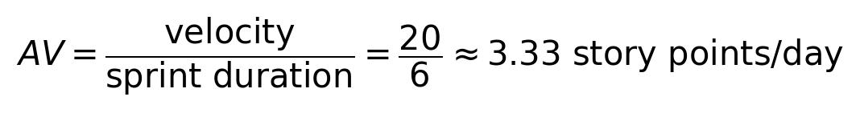

Burndown Chart:
A burn down chart is a graphical representation of work left to do versus time. It is often used in agile software development methodologies such as Scrum. However, burn down charts can be applied to any project containing measurable progress over time.
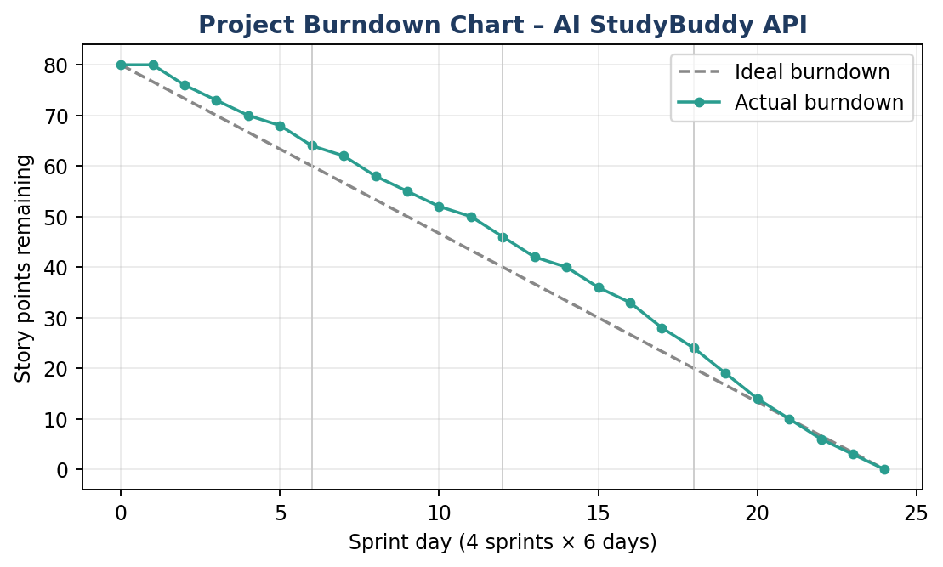

https://www.visual-paradigm.com/scrum/scrum-burndown-chart/
https://www.atlassian.com/agile/tutorials/burndown-charts

Reference:
https://www.atlassian.com/agile/project-management
https://www.atlassian.com/agile/tutorials/how-to-do-scrum-with-jira-software
https://www.atlassian.com/agile/tutorials/epics
https://www.atlassian.com/agile/tutorials/sprints
https://www.atlassian.com/agile/project-management/estimation
https://www.atlassian.com/agile/tutorials/burndown-charts

